Develop an instrumentation strategy
Design and implement logging
Design and implement telemetry
Integrate logging and monitoring solutions

Continuous monitoring - along CI/CD
Application monitoring
Infrastructure monitoring
Log storage/streaming
Log Analytics
Event Hub
Azure Storage Account

Azure Platform Logs
Activity logs
Resource logs

Azure Monitor

Platform as a service
Central solution for all logging needs

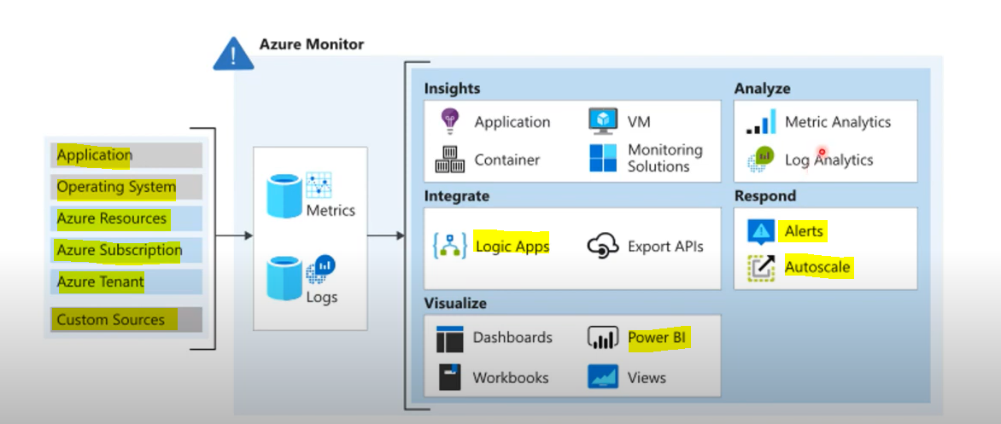

Application Insights

Application insights are used to attach with the web applications .

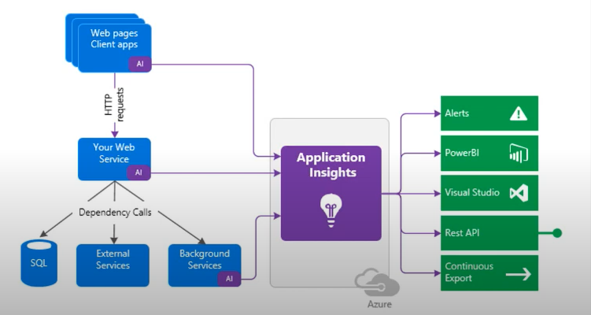

Design and implement telemetry
Performance Metrics
Requests per minute
Response times
Idle Connections
Service availability
CPU Utilization

